(Approx. 1433 words)

Project Management
By Dick Maybach, Member, Brookdale Computer Users’ Group, NJ
October 2016 issue, BUG Bytes
www.bcug.com
n2nd (at) att.net

Too often, especially in volunteer organizations, projects are undertaken with no provision for their management. As a result, they can take a long time to complete and too often are abandoned. Tools are available, such as the commercial Microsoft Project and the free ProjectLibre, that make it easier to manage even complex projects. Although I use ProjectLibre (http://www.projectlibre.com/) for this example, there are dozens of such programs, both proprietary and open source; see https://en.wikipedia.org/wiki/Comparison_of_project_management_software. Regardless, of which you use, the procedures are similar. If you decide to use ProjectLibre, a manual is available from their Website, under the Community tab. You may have to create an account to access it, but this hasn't caused any problems for me. When you click the download button, you are transferred to the SourceForge site, which in 2015 began engaging in unethical practices, including bundling malware with their downloads. This caused several large projects to withdraw their products from the site. SourceForge now has new owners, and the complaints seem to have abated, but you should be wary. Linux users should be able to find the program in their distribution's repository and so avoid this risk. Acquiring a tool of course doesn't make you a project manager any more than acquiring a hammer makes you a carpenter. You should do some reading to understand the process and vocabulary before you begin your work.

A good way to see how such a tool might help is to work through a simple example. Ours will be a club that currently keeps its members informed with a newsletter, but has decided to start a Web page to supplement and perhaps replace the newsletter. The club is run by a board of directors and has an editor for the newsletter. Available to work on the project are the board, the treasurer, the editor, and a club member with Website design experience who will function as the webmaster. The board meets on the first Monday of each month, and this will quantize the schedule. The editor estimates he will be able to work four hours per week on the Website, and the webmaster can work eight hours per week on it. The tasks that have to be accomplished are the following, with the responsible person in parentheses.

- Determine the features (board)
- Select a platform (webmaster)
- Select a vendor (treasurer)
- Approve the funds (board)
- Contract the vendor (treasurer)
- Architecture design (webmaster, 8 hours total)
- Assemble the content (editor, 16 hours total)
- Detailed site design (webmaster, 24 hours total)
- Approve the site (board)
- Publish the site

Most of the tasks must be accomplished serially, that is each one starts when the one above finishes.
- The platform choice depends on the features.
- The vendor must be able to support the platform.
- The funds required depend on the vendor and the services required from him.
- However, the architecture design can begin as soon as the features and platform are known.
- The editor can begin work on the content when the project starts.
- The detailed site design can proceed while the content is developing, but can't be completed until all the content is available.
- The board wants to see a complete site before it's approved.

We how have all the data we need to organize the project.

We first enter the individual tasks as well as the tasks on which they depend into the program. You use the left portion of Screen 1 as though it were a spreadsheet. In this case, we've entered only the task names and the numbers of the tasks that precede them. The program has entered default estimates of one day for each duration. (The question mark indicates an estimate.) When we started the program, we specified that the project would begin on September 1.

The right side of Screen 1 is a Gantt chart, a graphical representation of the spreadsheet view. The black arrows show the dependencies, the red bars are tasks “on the critical path,” and the blue bars are tasks that have slack time. “On the critical path” means that a delay of the task will delay the project. A task with slack time can be late (within limits) without affecting the project. At this initial stage, we've entered only the tasks and their dependencies.

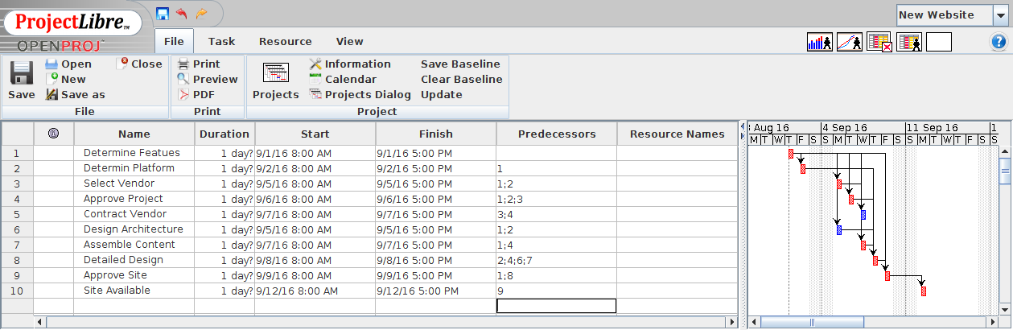
Screen 1. Initial Project Definition.

We next define our resources, which for this simple example are all people. A more complex project would also have material and tools. If our club had only one computer, which had to be shared by the editor and the webmaster, that would clearly affect the project, and we could use our tool to account for that. The program shows resources on another spreadsheet, Screen 2. Several columns aren't shown. For instance, we could assign different calendars to each person to account for their schedule. It's far simpler to use a standard 40-hour work-week calendar for everybody and if, for example someone has four hours per week available for club work, to assign ten per cent of that resource to a task.

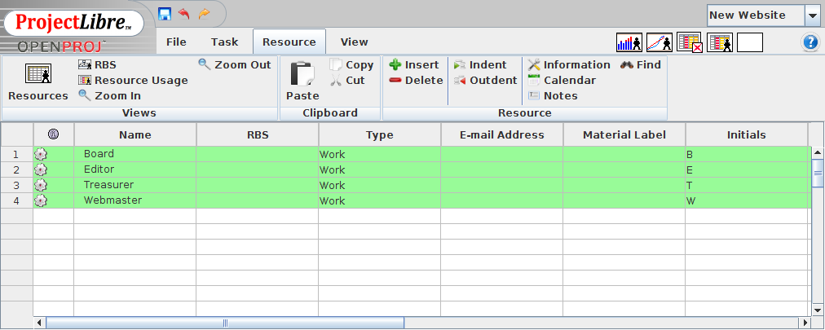
Screen 2. Define Resources.

We next open a task to add the details. In Screen 3 we've changed the amount of work for the Determine Features task to 4 hours (and the program changed its duration to 0.5 days) and cleared the Estimated box.

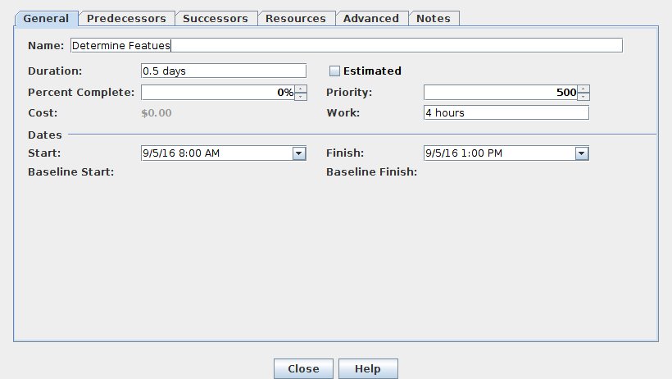
Screen 3. Enter the Work to Determine Features.

We also add the resources to each task. In Screen 4 we assign 20 per cent of the webmaster's 40-hour workweek to the task, since he can devote only eight hours per week to the project.

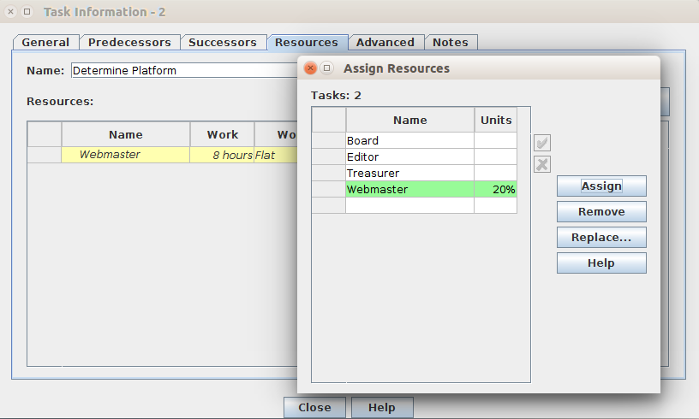
Screen 4. Assign the webmaster to the Determine Platform Task.

Another complication arises whenever the board is a resource, because they meet only on the first Monday of each month. As a result, the Determine Features task must take place on 9/5, Screen 5.

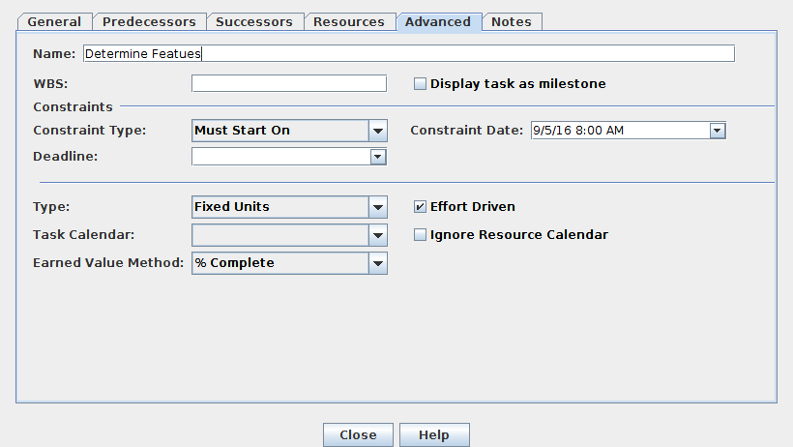
Screen 5. Set the Date for the Determine Features Task.

Finally, although the Assemble Content task is a predecessor for Detailed Design, the two can proceed in tandem. However, Detailed Design can't be completed until all the content is available. As a result, we change the type of this constraint to “FF” or “Finish-Finish,” meaning that the second task can't finish before the first, Screen 6.

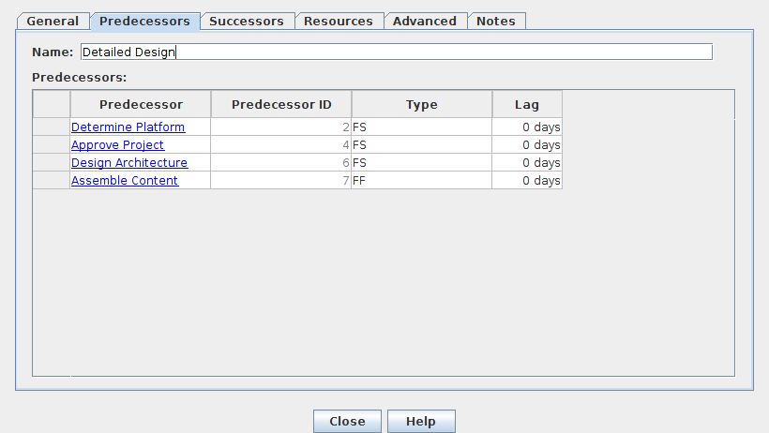
Screen 6. Set the Constraint that the Detailed Design Can't Complete Before Assemble Contents Does.

Our project view now appears as Screen 7.

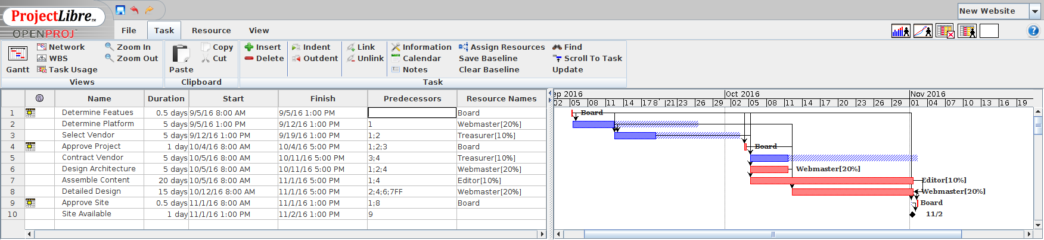
Screen 7. Completed Project.

We can see a problem. The entire design phase is on the critical path, which means that if anything takes longer than estimated, the project won't be finished in time to be approved at the November board meeting. Since the board meets only once per month, this will delay the project until December. Looking at the slack times (shown in blue crosshatch) suggests a solution. There is two weeks of slack time before the October board meeting. If the board held a special meeting in mid-September to approve the project, we could move two weeks of slack time to the design phase. Furthermore, having the team sitting around with nothing to do early in the project sends the message that the project and its schedule aren't important, which almost guarantees schedule slips.

Screen 8 shows the result of adding this board meeting. We now have a comfortable margin for our design phase and a better chance of completing the project on time.

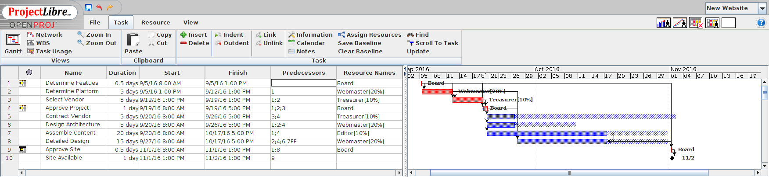
Screen 8. Project After Tuning.

I think of this and similar tools as TurboTax for projects. They do nothing you can't do with paper and pencil, and they don't relieve you of having to think, but they do remove much of the tedium from the job, especially while you make the inevitable changes. This example shows the importance of doing the planning early. If we had waited until after the project was approved at the September 5 board meeting to begin the planning, there wouldn't have been time to set up another meeting. About all the planning could then accomplish would be to explain why the project was late.

If you've never worked with a project planning tool, you'll need some time to experiment with the one you'll be using. You'll also need more time than you probably expect for your first project; expect several tries to get it right. I've found the results to be well worth the effort, as you can make clear to everyone working on the project how much time there is for each task and the consequences should one take longer than expected.

